### Plotting to get some information

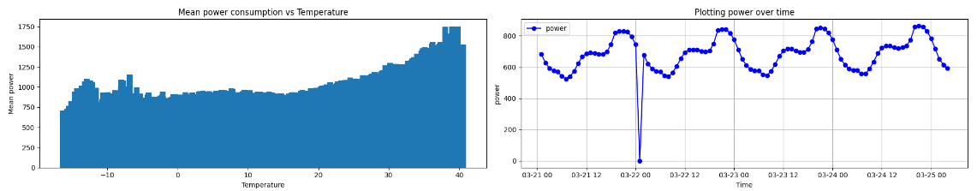

# Lightgbm Model

lightgbm" framework which uses tree based learning algorithms.

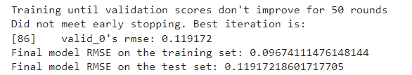

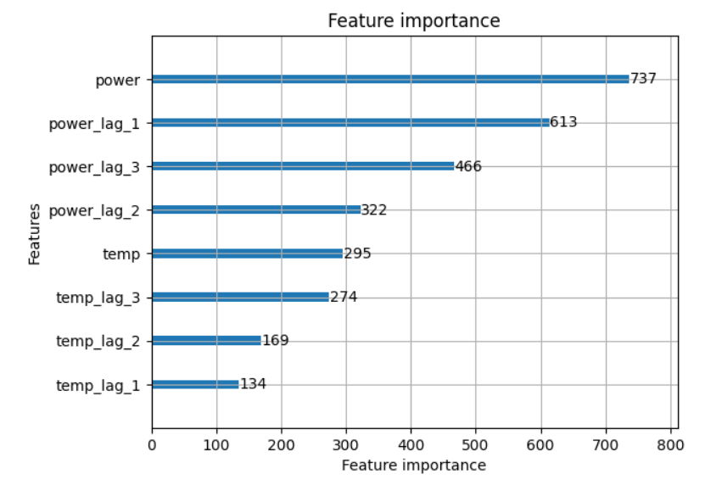

## Plotting the prediction vs actuals

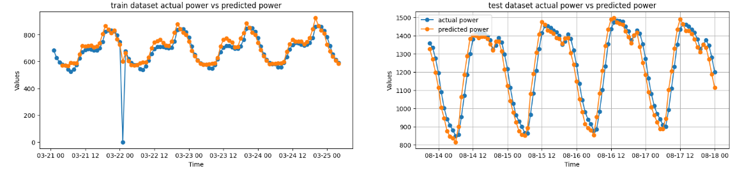

# -----------------------------------------

# Neural Network model

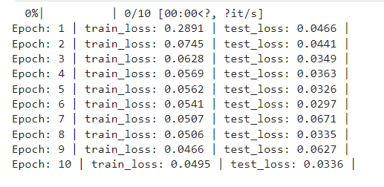

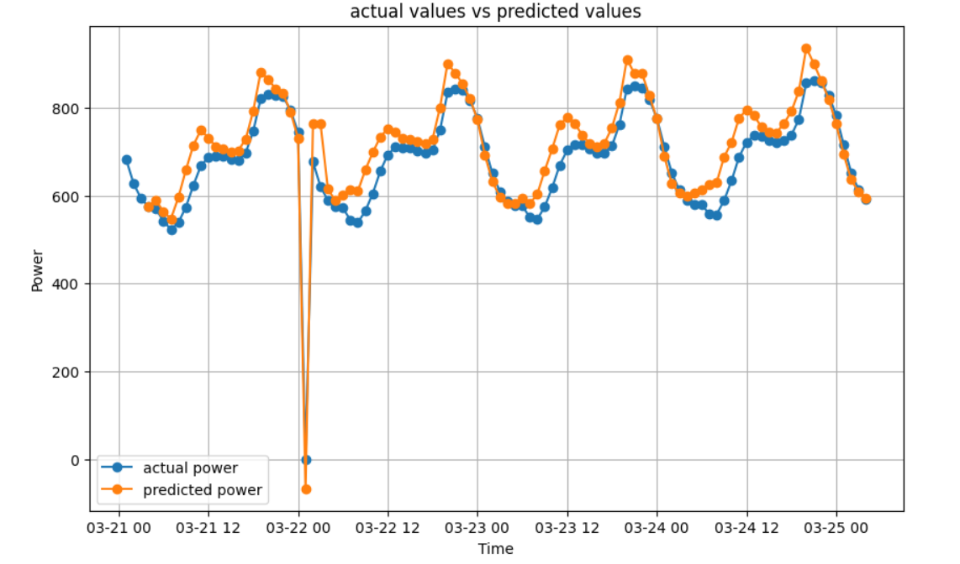

# ------------------------------------------

# LSTM model

